Week 5 assignment

1. Introduction

Ride comfort is defined as the overall comfort and well-being of the vehicle’s occupants during vehicle travel. The main sources of discomfort are oscillations which reach the vehicle’s passenger compartment and cause noise, vibration or both [1]. One of the main sources of these oscillations, subject of our study all along this project, is the roadway, and in this assignment, we aim to study the extreme cases of these vibrations, both in short- and long-term time histories. The output of the analysis will provide us an estimation of the behavior we can expect, useful in terms of potential design decisions.

1. Short-term estimation of maximum amplitude
   1. Estimation via rainflow cycling

To start off, a short-term estimation of the maximum amplitude of the load and response, an ensemble for load and response is created with load, RAO and response spectrum. The loading and response curves for a 1 km road are displayed in figure 1. The loading spectrum is defined with a pavement surface roughness described in paper [3].

**Fig. 1** Random loading and response curves simulating a real road profile

Then rainflow counting is applied to both ensembles to create a distribution of amplitudes. The rainflow of loading and response (figure 2 and 3) plots displays the probability of certain peak to peak values to occur during 15 km road profile. From the figure x and x displays that Rayleigh distributions are also fit to the histograms of the rainflow plots. The Rayleigh distribution fitting is done with 95% confidence interval. Thus, the peak defined from the distribution line is only applicable on 95% of the time. It can be seen from the figures that peak values as short-term estimation for a single road type is (black swans not included):

**Loading**

Histogram: 3.111 mm – 3 cycles

Rayleigh distribution: 3.124 mm – 1.348 cycles

**Response**

Histogram: 5.636 mm – 9 cycles

Rayleigh distribution: 5.796 mm – 0.6568 cycles

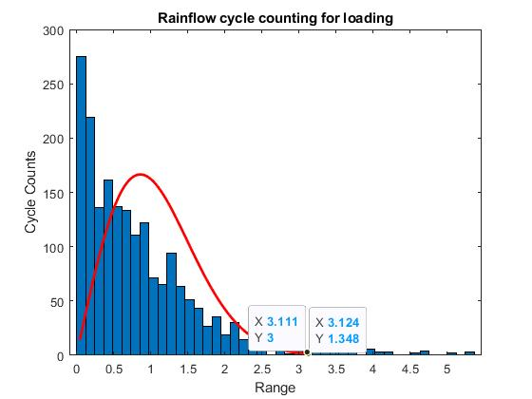

**Fig. 2** The rainflow for loading and fitting Rayleigh distribution of peak values

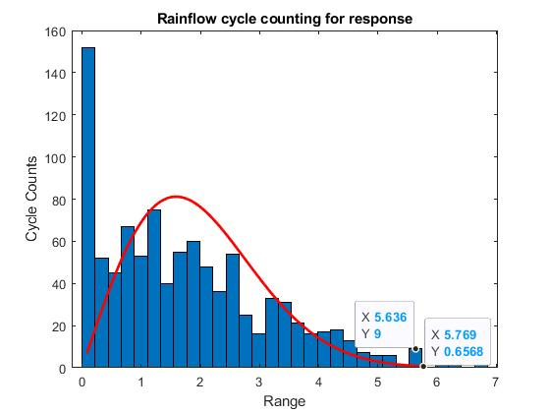

**Fig. 3** The rainflow for response and fitting Rayleigh distribution of peak values

The Rayleigh distribution is plotted due the fact that the it is inaccurate to define maximum values and their probability from histogram. Histogram is highly dependent on number of bins and measurement initializations. For example, if measurements initialization on a same road is done with in different locations, the histogram values of rainflow analysis would differ from each other. This can be seen as the difference in number of cycles in the peak value.

It also good to note that a single rainflow plot to define a Rayleigh distribution is not optimal in this case. This is due the fact that the process has not be proven to be ergodic during previous reports. Thus ideally, we should consider taking multiple ensembles and make a Rayleigh distribution over every plotted histogram. Or we should prove our process to be ergodic. In this case we assume our process to be ergodic therefore we are using only one ensemble. In the future researches, the ergodicness of the process will be considered.

* 1. Estimation via normal distribution

Then, normal distributions are applied to the loading and response curves. The normal distribution of the curves provides maximum values for both loading and response with their corresponding possibility. This differs from rainflow analysis since in the rainflow analysis, we studied peak to peak values. Now the maximum values display maximum displacements in both directions from a set zero or initial point for displacement. The normal distribution is done with also 95% confidence and similarly is applicable only on 95% of the time. The normal distributions for both loading and response can be seen in figures 4 and 5.

**Loading**

Max. positive value: 2.411 mm, p = 0.004737 = 0.4737 %

Max. negative value: -2.289 mm, p = 0.006721 = 0.6721%

**Response**

Max. positive value: 3.147 mm, p = 0.002313 = 0.2313%

Max. negative value: -3.053 mm, p = 0.003128 = 0.3128%

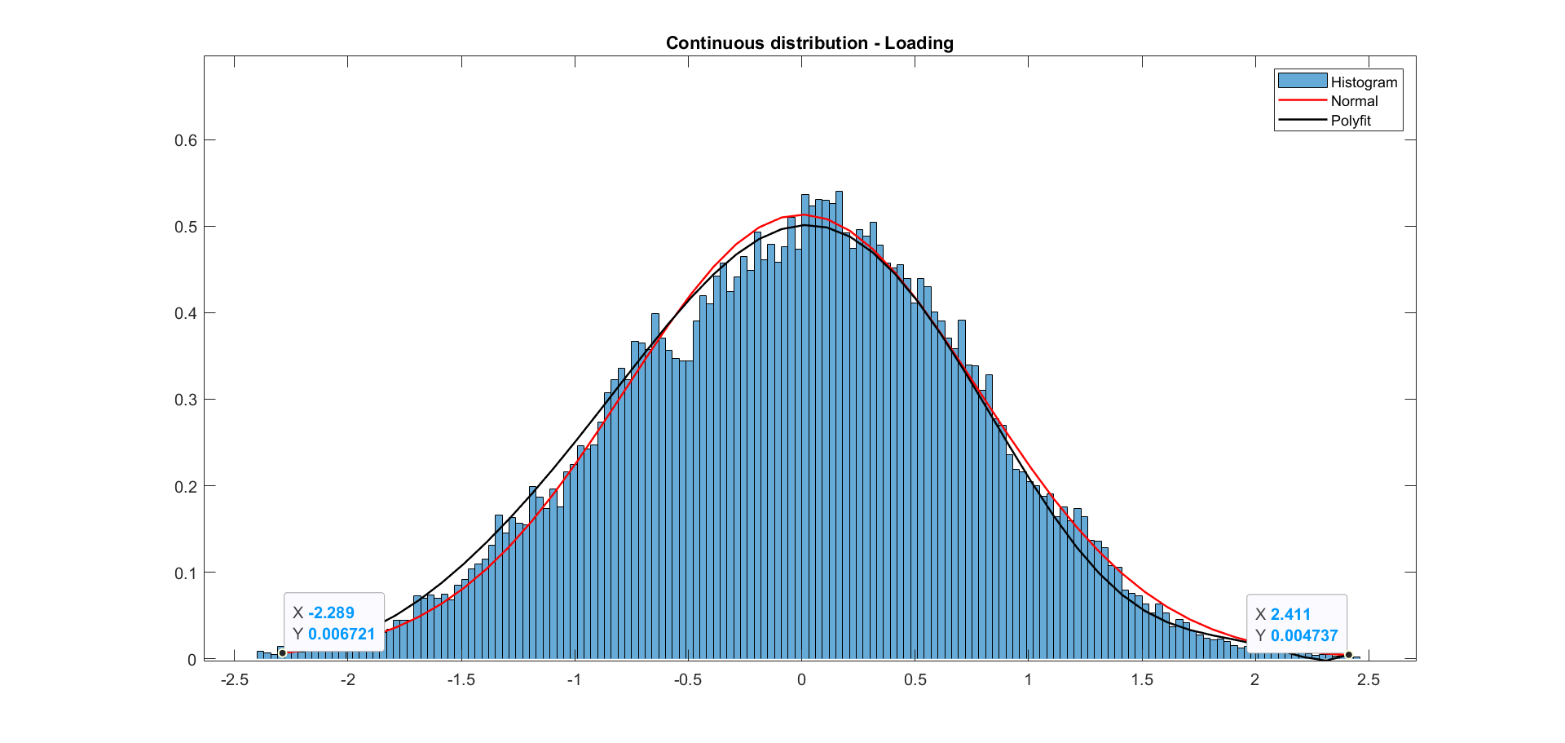

**Fig. 4** Normal distribution over loading, displayed as a histogram

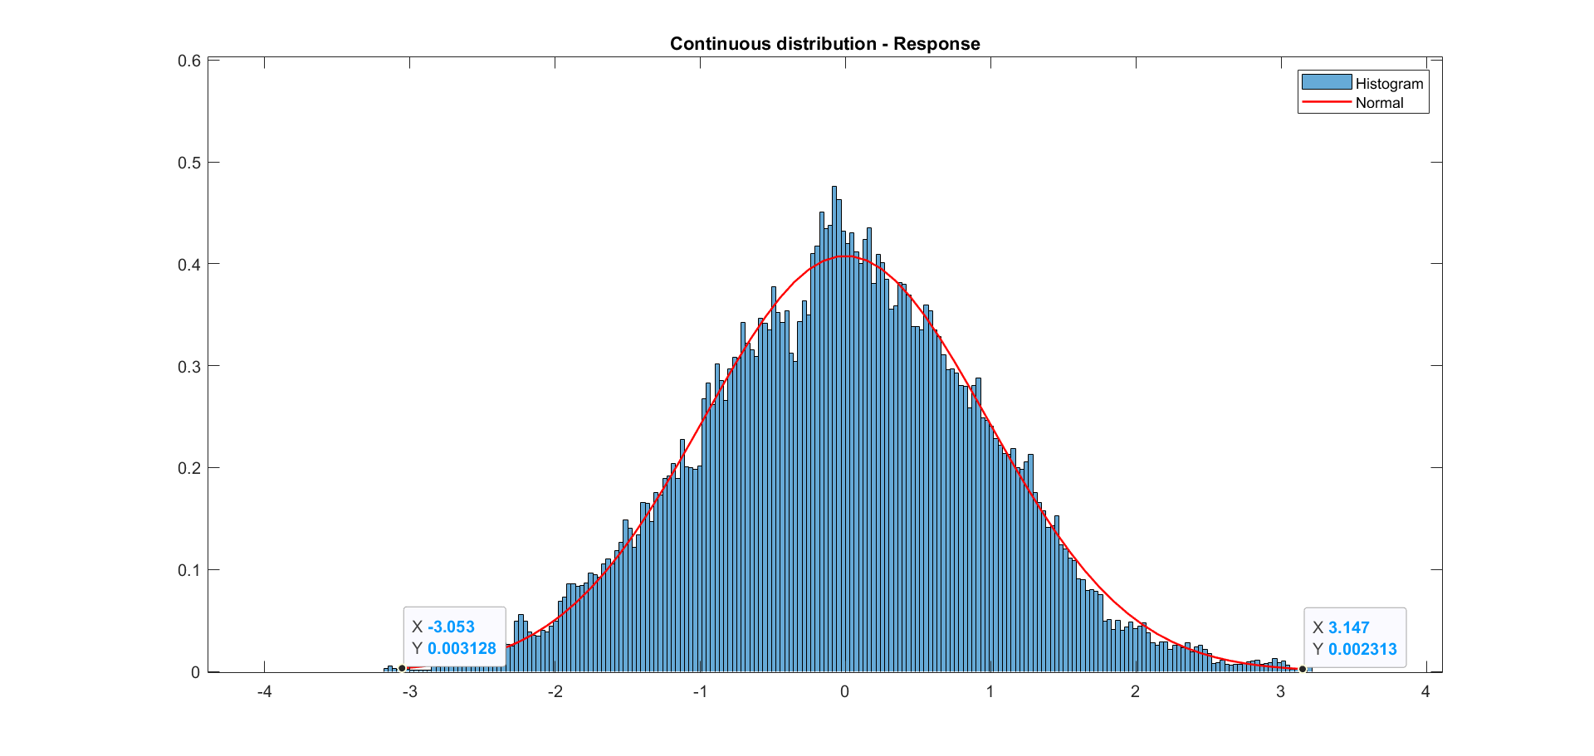

**Fig. 5** Normal distribution over response displayed as a histogram

Like assessed in previous phases of our project, we can see that when we plot a histogram of a random signal, for loading and response, the curve fits to the distribution closely to normal probability distribution. Red lines symbolise normal probability distribution for calculated standard deviations.

Standard deviation of load = 0.7185

Standard deviation of response = 1.0062

1. Long-term estimation of maximum amplitude
   1. Long term estimation

In order to define long term estimation for maximum values, another road type must be selected and analyzed. Since the loading spectrum is purely created with road surface roughness, the surface roughness values are changed to modify the spectrum. The loading spectrum is defined as

$$Sxx(Ω)={CΩ}^{-w}$$

where Ω [rad/m] is the angular spatial frequency, Ω=2π/L, where L is wavelength, C is unevenness index and w is the waviness (wavelength deviations). [3]

In the paper [3], there are multiple different road types with their corresponding unevenness indices defined. Few road types are listed in the table 1 below.

**Table 1.** Surface unevenness index for different road types, C [3]

|  |  |
| --- | --- |
| **Road type** | **Unevenness index, C * 10^(-6)** |
| Motorways | 0.011 |
| Pavement type 1 | 0.336 |
| Pavement type 2 (39500 3 OH) | 0.21 |
| Driveway (17585 4 IL) | 0.927 |

With driveway road type is selected from the table, a rougher road profile spectrum can be defined. With the new loading spectrum and predefined RAO, response spectrum can also be defined in the same method as done in previous reports. The loading spectrum and response spectrum of driveway compared to the previous spectrums can be seen in figure 6.

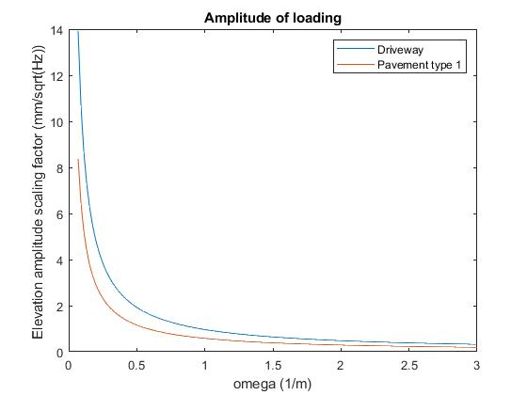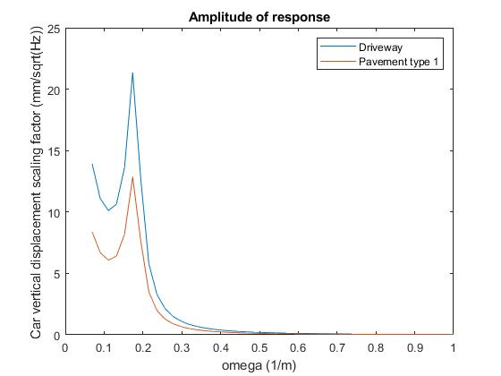

**Fig. 6** Scaling factor spectrum for random loading and response of the loading of the system

Then, the road elevation and response can be derived from the spectrums. The load and response curves can be seen in figure 7.

**Fig. 7** Random loading and response curves simulating a driveway

Then, the maximum peak to peak values for driveway can be defined with rainflow cycling (figures 8 and 9):

**Loading** 4.8 mm – 1.413 cycles

**Response** 9.282 mm – 0.7091 cycles

**Fig. 8** The rainflow for loading and fitting Rayleigh distribution of peak values - driveway

**Fig. 9** The rainflow for response and fitting Rayleigh distribution of peak values - driveway

In addition, we require possibilities for different road profiles in order to define long-term estimation. Since, it is highly depended on the environment where a vehicle is driven and who is driving the vehicle, it is hard to give accurate probability values for different road types. Thus, if we assume that a vehicle is driven in normal weather conditions (dry road) in Finland, some estimates of probability from our own experience can be given for different road types.

**Table 2.** Estimations for probabilities for different road types in Finland (own experience).

|  |  |
| --- | --- |
| **Road type** | **Probability** |
| Motorways | 0.6 / 60% |
| Pavement type 1 | 0.2 / 20% |
| Pavement type 2 (39500 3 OH) | 0.15 / 15% |
| Driveway (17585 4 IL) | 0.05 / 5% |

In order to calculate data points for long term estimation, peak to peak values and their corresponding possibility to happen in long-term must be defined. This is done by multiply the probabilities for a road type with the probability for the peak to peak value of the road type. The peak to peak values and their number of cycles are displayed in table 3.

**Table 3.** Maximum peak to peak values and their corresponding probabilities for different road types.

|  |  |  |  |  |
| --- | --- | --- | --- | --- |
|  | **Loading** | | **Response** | |
| **Road type** | **Cycles, nL** | **Pk-Pk value, yL** | **Cycles, nR** | **Pk-Pk value, yR** |
| Pavement type 1 | 0.2*1.348 | 3.124 mm | 0.2*0.656 | 5.796 mm |
| Driveway (17585 4 IL) | 0.05*0.7091 | 4.8 mm | 0.05*0.709 | 9.282 mm |

Then, the maximum estimations are plotted according to the table 3. Figure 9 displays long-term estimations of maximum peak to peak values and their corresponding probability for both loading and response. The average amount of cycles in process is 1000.



**Fig. 9.** Long-term estimation of maximum peak to peak values of loading and response. Road types as pavement type 1 and driveway.

* 1. Lifetime estimations term

Then in order to define lifetime estimations for maximum peak to peak values and their probabilities for loading and responses, loading spectrum were defined for other 2 types of road. Then with the loading spectrums of the roads, response spectrum was also created. Then with the same methodology, ensembles of the road types were generated and then analyzed with rainflow cycling. Finally, peak to peak values and their probabilities were defined from the rainflow plots. All road types with their maximum value estimations and occurrence probabilities are described in table 4.

**Table 4.** Maximum value estimations of loading and response for all road types.

|  |  |  |  |  |
| --- | --- | --- | --- | --- |
|  | **Loading** | | **Response** | |
| **Road type** | **Cycles, nL** | **Pk-Pk value, yL** | **Cycles, nR** | **Pk-Pk value, yR** |
| Motorways | 0.6 *1.323 | 0.525 mm | 0.6*0.651 | 0.957 mm |
| Pavement type 1 | 0.2 * 1.348 | 3.124 mm | 0.2 * 0.6568 | 5.796 mm |
| Pavement type 2 (39500 3 OH) | 0.15 * 1.508 | 0.957 mm | 0.15*0.632 | 5.047 mm |
| Driveway (17585 4 IL) | 0.05 * 0.7091 | 4.8 mm | 0.05 * 0.7091 | 9.282 mm |

With the values from table 4, lifetime estimation plots were done for both loading and response. The average amount of cycles in process is 1000. Figure 10 displays lifetime estimations from which it can be noticed that the dots are forming a Weibull distribution.



**Fig. 10.** Lifetime estimation of maximum peak to peak values of loading and response.

1. Discussion
   1. Comfort Standards Definition – Comfort Vibration Limits

The contact between the tire and the roadway is the main source of vibrations and oscillations in the vehicle. When driving over uneven road surfaces, the wheel follows the topography of the roadway. The exact motion of the wheel is dependent on vehicle properties including the tire radius, unsprung mass, and deformation behavior. Standard roadway types (freeways, city streets, and country roads) can be classified according to standardized measurements of the surface power spectral density over the wavelength. For vehicle speeds of up to 200 km/h, low frequency excitations (below 50 Hz) with wavelengths between 150 mm and 90 m are particularly detrimental to ride comfort [1].

Figure 2 below provides standard values for passenger comfort against vertical vehicle oscillation that in theory should frame our long-term (whole lifetime) analysis.

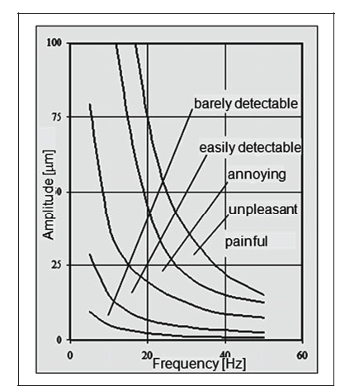

Figure 2: Human perception range (vertical motion) [1]

However, for the purpose of this course there are some things that must be taken into consideration to understand our analysis process followed:

* During the first phase, we stated that our system would consist of a semi-active suspension system. In simple words, the job of suspension in automotive vehicles is to provide comfort, steering stability and good handling in different road conditions. Therefore, the frequencies for human perception range, and therefore a precise long-term probability estimation are difficult to predict, and therefor difficult to relate to Figure 2, at least for the matter of this course.
* For simulation and analysis reasons, we have been considering a constant damping value. This means that the RAO can’t be applied to the system presented in the first place, where the damper was stated to be a controllable one. Anyways, what we have been doing is applying stochastic processes to gather the data and predictions we present, that then would be used to design, assemble or tune this adjustable damper.

However, we are aimed to study the long-term probability distribution further, and the effect this would have on passenger comfort further by backgrounding our analysis with literature research. The study [2], carried out a series of tests on 3 different road types with the aim of determining the impact of random interferences resulting from a changing environment. For this purpose, the criterion for the evaluation of the road surface condition was developed on the basis of longitudinal vibrations of the car body of the tested car in the speed range from 50 km/h to 110 km/h. Selected functions such as: probability distribution and methods in the frequency domain: short-time Fourier transform (STFT) and power spectral density (PSD) were used to analyze recorded signals. [2] The results of this analysis can be used to discuss the effect of in-car vibrations in passengers, applied to a longer lifespan than the previously analyzed, short term distribution.

During the tests, the authors tried to maintain a constant linear velocity with accuracy (+/- 5 km/h) for selected speed ranges (from 50 km/h to 90 km/h). The car body acceleration recording time was established in such a way that it included at least 20-wheel rotations. The autocorrelation function, power spectral density, short-time Fourier transform (STFT) and probability distribution were used for the analysis of data obtained under stationary conditions and in road tests for bituminous surfaces defined as road A (without visible surface defects), B (with visible surface defects) and C (with considerable surface defects – extreme conditions). [2]

In amplitude spectra obtained for tests carried out with balanced wheels there is a multiple increase in the amplitude of vibrations of the car body in the longitudinal direction (x axis) and in the vertical direction (y axis) for tests carried out on roads B and C in relation to road A and test-stand measurements. [2]

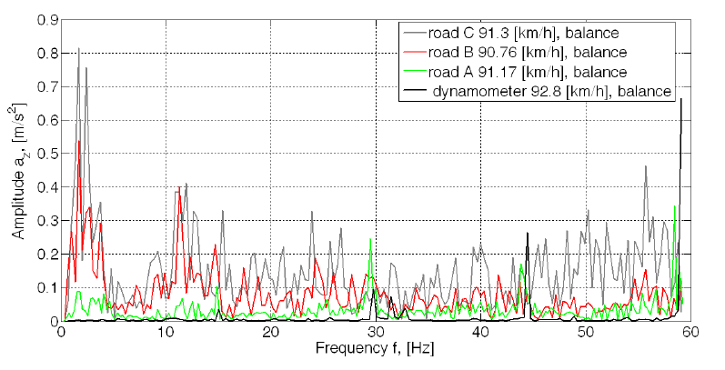

Figure 3: Amplitude of vibrations of the car body for selected types of road surfaces

A, B and C in the vertical direction [2]

Dominating amplitudes for speed from 90 km/h to 92 km/h occur in the frequency range from 5 Hz to 25 Hz. These are indeed noticeable for the passenger, but thanks to their estimation, tuning the damper of the suspension system is possible and necessary, since at the moment, the frequencies measured directly from the raw data are within an unpleasant range.

Long term distribution is a cumulative sequence of short-term distributions. Also, when talking about whole life-time estimation analysis processes, there are more probabilities of getting worse results for the estimated extreme peak values. So, in other words the more tests we run on different types of roads, or the longer journeys we make with the vehicle, the more peak possibilities we will take into consideration, and the better our analysis will be. However, for our case, we have to consider than when talking about the effect of road surface in vertical displacement, and the effect of passenger comfort, we can’t apply the theories of fatigue study, in the sense that these don’t follow a logarithmic behavior.

In summary, in round 1, the short-term and long-term probability distribution on road profile are discussed and they are subordinated to Gaussian distribution and Rayleigh distribution, respectively. When it comes to the Round 5, the main points are emphasis on peak values during short-term and long-term travelling process. On the one hand, whenever in round 1 or round 5, the probability distribution either with road profile or with various wave peaks is subordinated to Gaussian distribution in short-term process. On the other hand, from the view of lifetime, the probability is subordinated to Rayleigh distribution, whenever the rainflow analysis method is applied in different road types or the probability distribution of long-term road situation. Possibly, the probability of maximum points also represented as peak value can be captured more times when travelling time is enough long (equal to different road situation). Now that the probability distribution of road profile is subordinated to Rayleigh distribution, if we only consider those peak values, they seem also be subordinated to the same distribution with road profile.

**Reference**

[1] Heißing B., Ersoy M. (2011) Ride Comfort and NVH. In: Heißing B., Ersoy M. (eds) Chassis Handbook. Vieweg+Teubner. <https://doi.org/10.1007/978-3-8348-9789-3_5>

[2] Pra, Kaa & Mamala, J. (2020). Classification of the road surface condition on the basis of vibrations of the sprung mass in a passenger car. IOP Conference Series: Materials Science and Engineering. 148. 10.1088/1757-899X/148/1/012022.

[3] Kropáč, O. and Múčka, P., 2008. Deterioration model of longitudinal road unevenness based on its power spectral density indices. Road materials and pavement design, 9(3), pp.389-420.